**Software Engineering Assignment**

**Module:1(SDLC)**

* **What is Software? What is software engineering?**

Software is a program or set of programs containing instructions that provide desired functionality. And Engineering is the process of designing and building something that serves a particular purpose and finds a costeffective solution to problems.

Software Engineering is the process of designing, developing, testing, and maintaining software. It is a systematic and disciplined approach to software development that aims to create high-quality, reliable, and maintainable software. Software engineering includes a variety of techniques, tools, and methodologies, including requirements analysis, design, testing, and maintenance.

* **Explain types of software?**

Application software. The most common type of software, application software is a computer software package that performs a specific function for a user, or in some cases, for another application. An application can be self-contained, or it can be a group of programs that run the application for the user. Examples of [modern applications i](https://www.techtarget.com/searchcio/feature/The-rise-of-modern-applications-Why-you-need-them)nclude office suites, graphics software, databases and database management programs, web browsers, word processors, software development tools, image editors and communication platforms.

System software. These software programs are designed to run a computer's application programs and hardware. System software coordinates the activities and functions of the hardware and software. In addition, it controls the operations of the computer hardware and provides an environment or platform for all the other types of software to work in. The OS is the best example of system software; it manages all the other computer programs. Other examples of system software include the [firmware,](https://www.techtarget.com/whatis/definition/firmware) computer language translators and system [utilities.](https://www.techtarget.com/whatis/definition/utility)

* **What is SDLC? Explain each phase of SDLC**

A software life cycle model (also termed process model) is a pictorial and diagrammatic representation of the software life cycle. A life cycle model represents all the methods required to make a software product transit through its life cycle stages. It also captures the structure in which these methods are to be undertaken.

In other words, a life cycle model maps the various activities performed on a software product from its inception to retirement. Different life cycle models may plan the necessary development activities to phases in different ways. Thus, no element which life cycle model is followed, the essential activities are contained in all life cycle models though the action may be carried out in distinct orders in different life cycle models. During any life cycle stage, more than one activity may also be carried out.

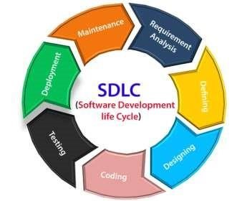

The stages of SDLC are as follows:

# Stage1: Planning and requirement analysis

* Requirement Analysis is the most important and necessary stage in SDLC.
* The senior members of the team perform it with inputs from all the stakeholders and domain experts or SMEs in the industry.
* Planning for the quality assurance requirements and identifications of the risks associated with the projects is also done at this stage.
* Business analyst and Project organizer set up a meeting with the client to gather all the data like what the customer wants to build, who will be the end user, what is the objective of the product. Before creating a product, a core understanding or knowledge of the product is very necessary.
* **For Example**, A client wants to have an application which concerns money transactions. In this method, the requirement has to be precise like what kind of operations will be done, how it will be done, in which currency it will be done, etc.
* Once the required function is done, an analysis is complete with auditing the feasibility of the growth of a product. In case of any ambiguity, a signal is set up for further discussion.
* Once the requirement is understood, the SRS (Software Requirement Specification) document is created. The developers should thoroughly follow this document and also should be reviewed by the customer for future reference.

# Stage2: Defining Requirements

* Once the requirement analysis is done, the next stage is to certainly represent and document the software requirements and get them accepted from the project stakeholders.
* This is accomplished through "SRS"- Software Requirement Specification document which contains all the product requirements to be constructed and developed during the project life cycle.

# Stage3: Designing the Software

➢ The next phase is about to bring down all the knowledge of requirements, analysis, and design of the software project. This phase is the product of the last two, like inputs from the customer and requirement gathering.

# Stage4: Developing the project

➢ In this phase of SDLC, the actual development begins, and the programming is built. The implementation of design begins concerning writing code. Developers have to follow the coding guidelines described by their management and programming tools like compilers, interpreters, debuggers, etc. are used to develop and implement the code.

# Stage5: Testing

* After the code is generated, it is tested against the requirements to make sure that the products are solving the needs addressed and gathered during the requirements stage.
* During this stage, unit testing, integration testing, system testing, acceptance testing are done.

# Stage6: Deployment

* Once the software is certified, and no bugs or errors are stated, then it is deployed.
* Then based on the assessment, the software may be released as it is or with suggested enhancement in the object segment.
* After the software is deployed, then its maintenance begins.

# Stage7: Maintenance

* Once when the client starts using the developed systems, then the eal issues come up and requirements to be solved from time to time.
* This procedure where the care is taken for the developed product is known as maintenance.

 **What is DFD? Create DFD diagram on Flipcart.**

A data flow diagram (DFD) maps out the flow of information for any process or system. It uses defined symbols like rectangles, circles and arrows, plus short text labels, to show data inputs, outputs, storage points and the routes between each destination. Data flowcharts can range from simple, even hand-drawn process overviews, to in-depth, multi-level DFDs that dig progressively deeper into how the data is handled. They can be used to analyze an existing system or model a new one. Like all the best diagrams and charts, a DFD can often visually “say” things that would be hard to explain in words, and they work for both technical and nontechnical audiences, from developer to CEO. That’s why DFDs remain so popular after all these years. While they work well for data flow software and systems, they are less applicable nowadays to visualizing interactive, realtime or database-oriented software or systems.

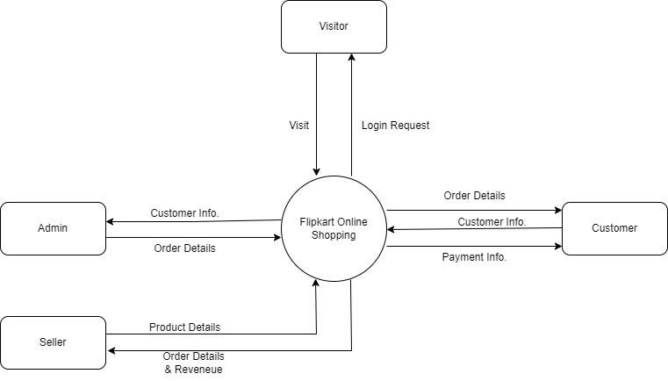

Level 0

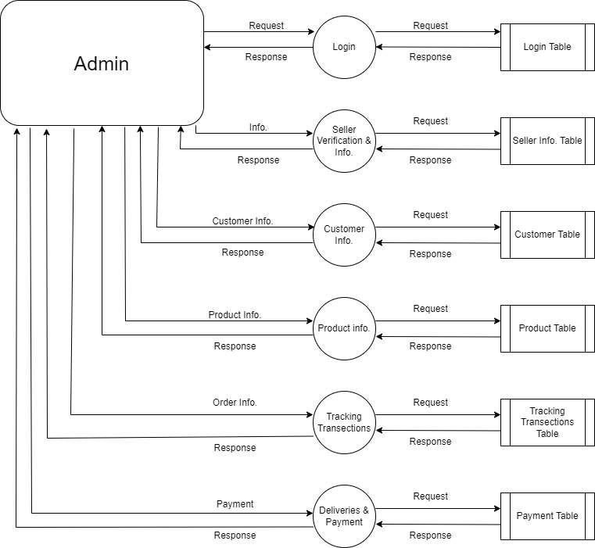

Level 1

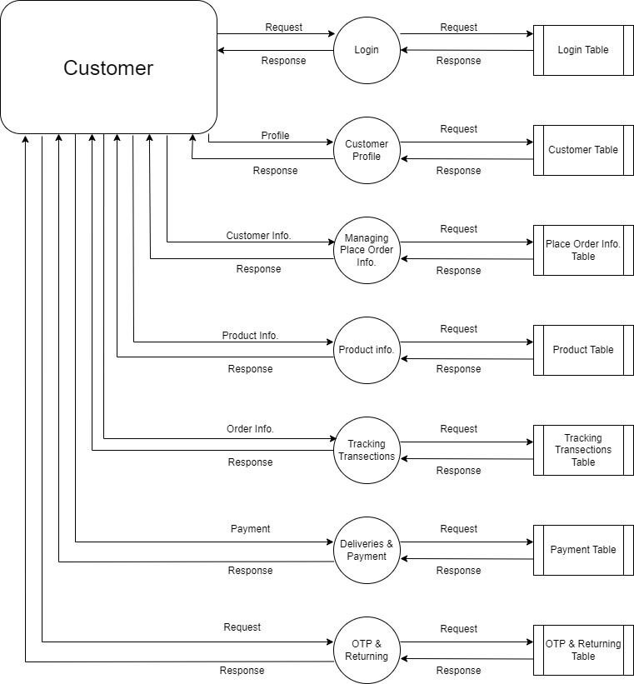

Level 2

* **What is Flow chart? Create a flowchart to make addition of two numbers.** 
  + flowchart is a diagram that shows the flow of information for a process/workflow. Therefore, it's also known as a process flow diagram. This flow of information, and it's subsequent processing, is depicted using various connected symbols.
  + In software engineering, flowcharts show the flow of information for algorithms. However, note that flowcharts are drawn independently of any programming language.

**Create a flowchart :**

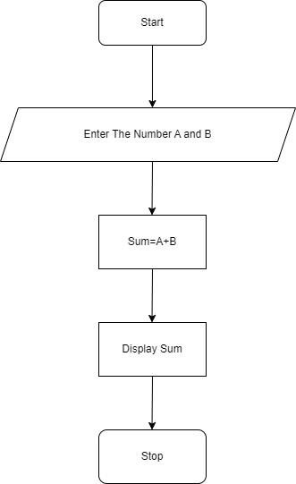

* **What is Use case Diagram? Create a use-case on bill payment on paytm.**

➢ A use case diagram is used to represent the dynamic behavior of a system. It encapsulates the system's functionality by incorporating use cases, actors, and their relationships. It models the tasks, services, and functions required by a system/subsystem of an application. It depicts the high-level functionality of a system and also tells how the user handles a system.

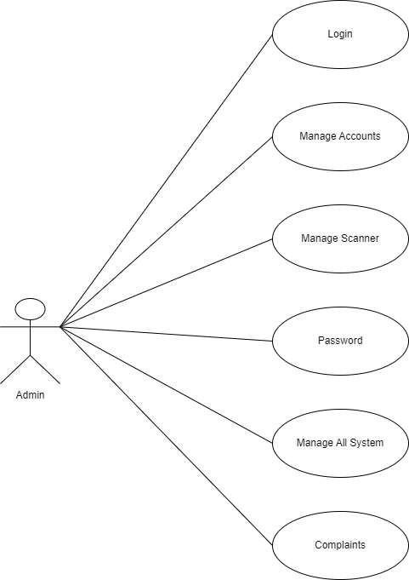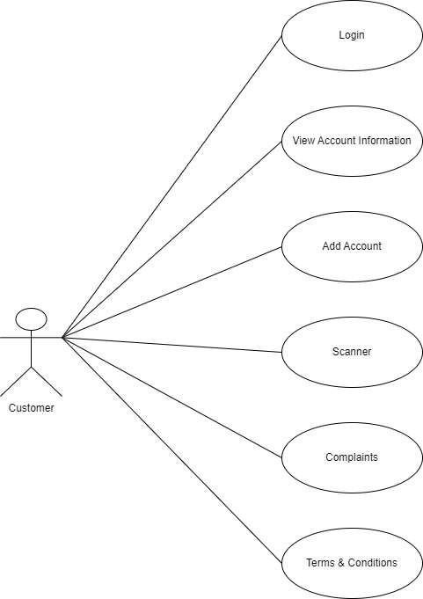

# ADMIN CUSTOMER